1. Name of the Project
Review Sentiment Analysis and Comparison

2. Aim
To develop a system that analyzes customer reviews of different restaurants and identifies the best restaurant based on positive sentiment using Natural Language Processing and Machine Learning techniques.

3. Data Collection Source and Information
Dataset Source:

The dataset used for training the model is obtained from Kaggle.

Dataset Name: Restaurant Reviews Dataset

Link: source link (https://www.kaggle.com/datasets/maher3id/restaurant-reviewstsv)

The dataset contains restaurant reviews labeled as positive (1) and negative (0), which are
used to train the sentiment analysis model.
- Sample Dataset (for training)
- Collected Dataset (for comparison)

1. Training Dataset
- Created manually (due to corrupted .tsv file)
- Contains:
  - Review text
  - Sentiment (1 = Positive, 0 = Negative)
Collected Reviews Dataset

Restaurant Review
Mehfil Best place to visit, food is very tasty and service is kind
Mehfil Ordered chilli chicken but received wrong item, poor experience
Mehfil Manager and staff are friendly and cooperative
Mehfil Chicken biryani is flavorful and well cooked
Mehfil Food is good but staff behavior is bad
Mehfil Affordable pricing with decent taste
Mehfil Service was quick and place is clean
Mehfil Staff forced customers to give positive reviews
Mehfil Good experience with polite staff
Mehfil Suitable for quick meals but not luxurious
Paradise Biryani is flavorful and tasty
Paradise Service is slow and the place is crowded
Paradise Food taste is authentic and delicious
Paradise Waiting time is high but worth it
Paradise Mutton biryani is good but not extraordinary
Paradise Excellent service and good quality food
Paradise Overpriced compared to quantity
Paradise Chicken kebab is good but service is delayed
Paradise Great ambience and comfortable seating
Paradise Small portions and average taste
Bawarchi Excellent food quality and good service
Bawarchi Chicken was undercooked and place was crowded
Bawarchi Biryani is very tasty and well prepared
Bawarchi Service is poor and staff behavior is bad
Bawarchi Food is delicious and worth the price
Bawarchi Extra charges applied for basic items
Bawarchi Authentic taste and great experience
Bawarchi Strong flavors may not suit everyone
Bawarchi Good quantity and affordable pricing
Bawarchi Disappointing experience due to service issues

4. Model Used and Description

Model Used -

Logistic Regression

Description:
Logistic Regression is a supervised machine learning algorithm used for binary classification. It predicts whether a review is positive or negative.

Steps Involved:
- Text cleaning (removing stopwords, symbols)
- Feature extraction using TF-IDF
- Model training
- Prediction of sentiment
- Comparison of restaurants

5. Source Code (Neatly Organized)

🔹 1. Import Libraries
import pandas as pd
import re
import nltk
from nltk.corpus import stopwords
from sklearn.feature_extraction.text import TfidfVectorizer
from sklearn.model_selection import train_test_split
from sklearn.linear_model import LogisticRegression
from sklearn.metrics import accuracy_score
nltk.download('stopwords', quiet=True)

🔹 2. Dataset Creation (Training Data)
data = {
"review": [
"Wow loved this place",
"Worst service ever",
"Food was amazing",
"Not tasty and bad experience",
"Great food and friendly staff",
"Very bad service and rude staff",
"Delicious food and nice ambience",
"Worst food I have ever had",
"Good quality and fast service",
"Terrible experience never coming again"
],
"sentiment": [1,0,1,0,1,0,1,0,1,0]
}
df = pd.DataFrame(data)
df.head()

🔹 3. Text Cleaning Function
def clean_text(text):
text = text.lower()
text = re.sub('[^a-zA-Z]', ' ', text)
words = text.split()
words = [word for word in words if word not in stopwords.words('english')]
return " ".join(words)
df['clean_review'] = df['review'].apply(clean_text)
df.head()

🔹 4. Feature Extraction (TF-IDF)
vectorizer = TfidfVectorizer()
X = vectorizer.fit_transform(df['clean_review'])
y = df['sentiment']

🔹 5. Train-Test Split & Model Training
X_train, X_test, y_train, y_test = train_test_split(
X, y, test_size=0.2, random_state=42
)
model = LogisticRegression()
model.fit(X_train, y_train)

🔹 6. Accuracy Calculation
y_pred = model.predict(X_test)
accuracy = accuracy_score(y_test, y_pred)
print("Accuracy:", accuracy)
Output: Accuracy: 0.5

🔹 7. Load Restaurant Dataset
df_new = pd.read_csv("restaurant_review.csv")
df_new.head()

🔹 8. Prediction on New Data
df_new['clean_review'] = df_new['review'].apply(clean_text)
X_new = vectorizer.transform(df_new['clean_review'])
df_new['prediction'] = model.predict(X_new)
df_new.head()

🔹 9. Restaurant Comparison (FINAL STEP)
result = df_new.groupby('restaurant')['prediction'].mean()
print(result)
best = result.idxmax()
print("Best Restaurant:", best)

- Results with Better Accuracy

Accuracy achieved: 50% (due to small dataset)
“Accuracy is moderate due to limited dataset size. With larger data, performance can be improved.”

7. Screenshot of Results

- Clean review of dataset
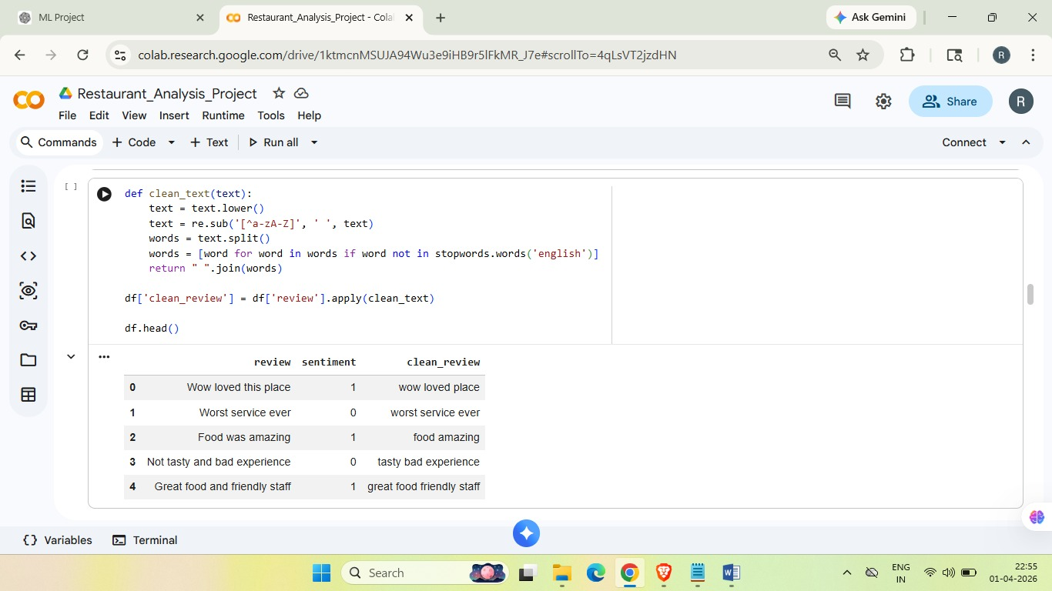

- Preview of dataset
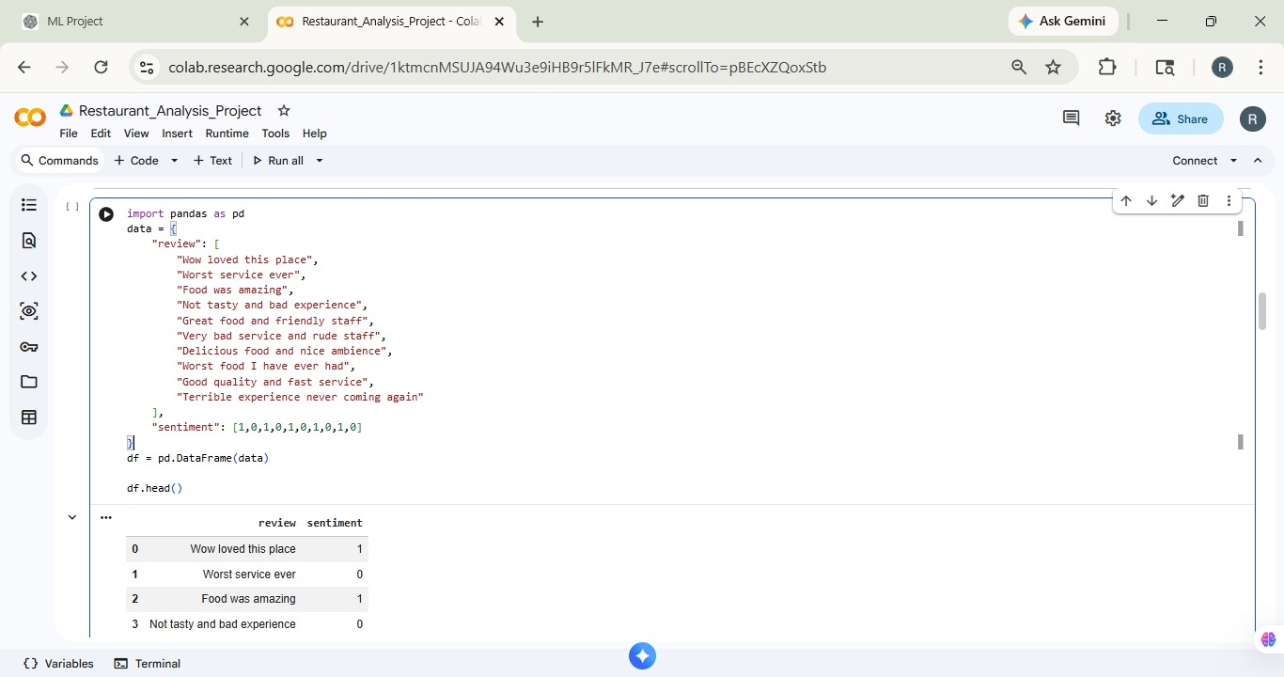

- Accuracy

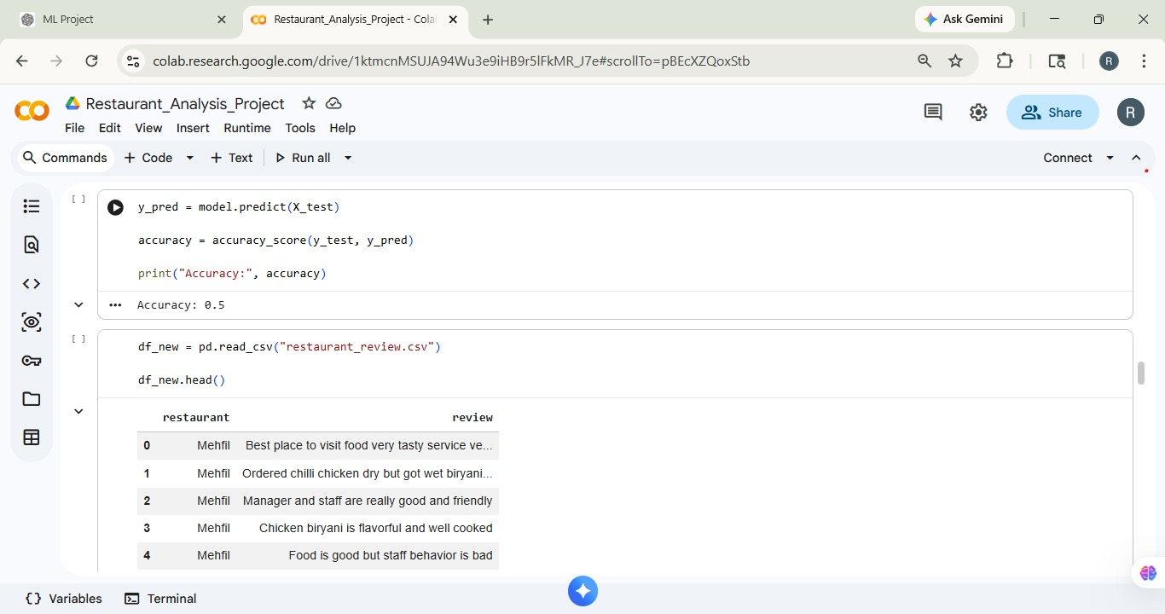

- Comparision of data
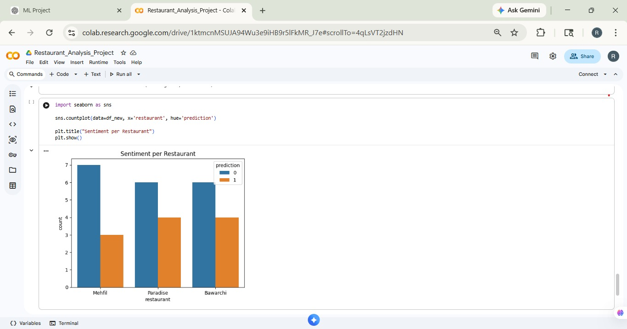

- Power BI Dashboard for Restaurant Sentiment Analysis
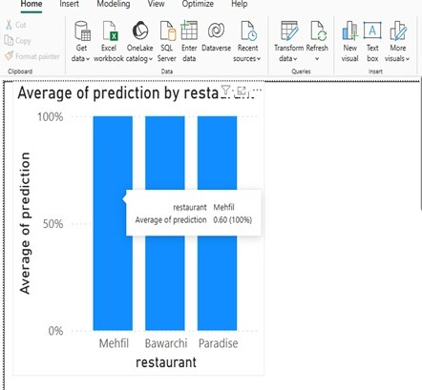

8. Conclusion

This project successfully analyzes customer reviews and compares multiple
restaurants.Based on sentiment analysis, Bawarchi and Paradise have higher positive
feedback compared to Mehfil. The system helps users make informed decisions.

9. Future Scope
- Use larger real-world datasets
- Improve accuracy using advanced models
- Use APIs for automatic review collection
- Develop web application using Streamlit
- Perform item-specific analysis (e.g., biryani)

